**Creating Microservices for account and loan**

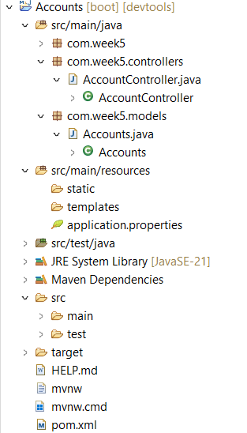

Pom.xml

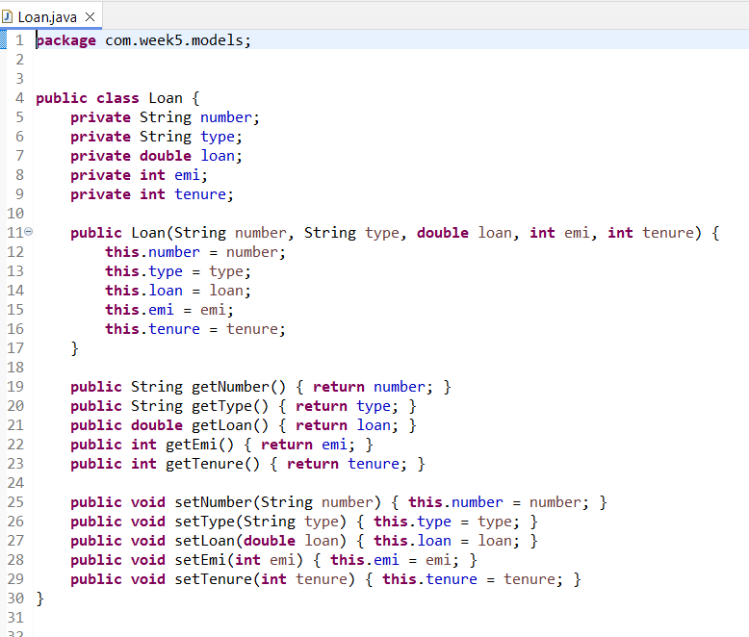

Outputs:

http://localhost:1980/accounts/4991980

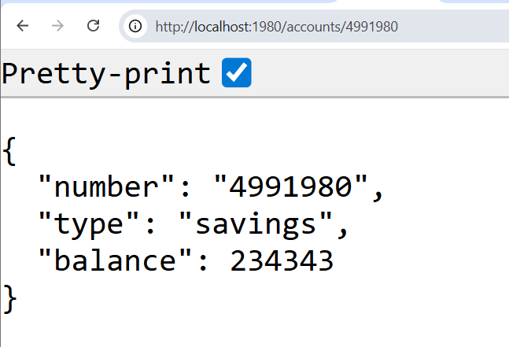

http://localhost:1981/loans/4991980

